📊 Customer Shopping Behavior – Data Cleaning & Transformation Summary
🔹 1. Data Loading
- Imported required libraries: NumPy and Pandas
- Loaded dataset from CSV file:
  - customer_shopping_behavior.csv

🔹 2. Initial Data Exploration
- Viewed first few records using:
  - df.head()
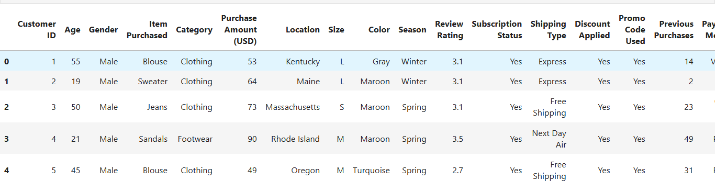
- Checked dataset structure:
  - df.info()
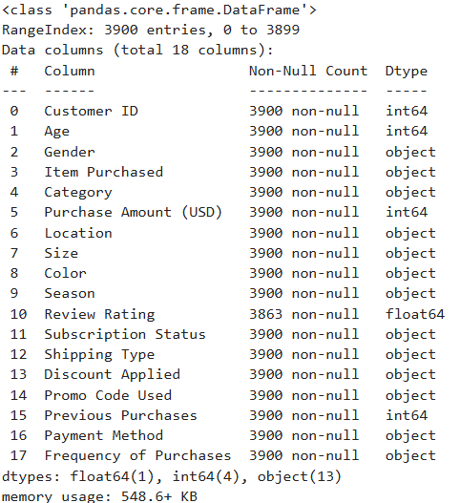

Generated statistical summary:
  - df.describe()
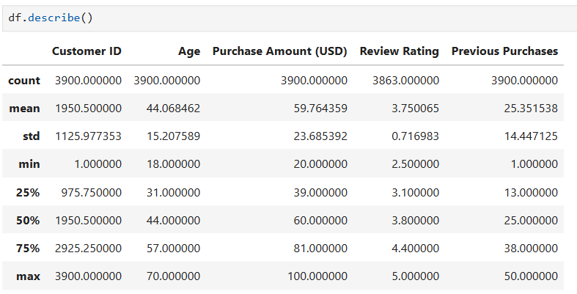
- Identified missing values:
  - df.isnull().sum()
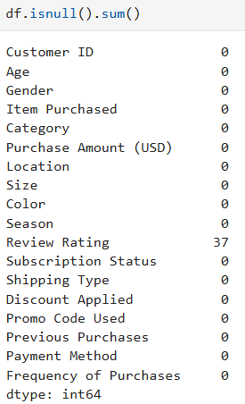

🔹 3. Handling Missing Values
- Found missing values in Review Rating column
- Applied group-based median imputation:
  - Filled missing values using median rating per Category
- Ensured no null values remain after transformation
- df['Review Rating']=df.groupby('Category')['Review Rating'].transform(lambda x:x.fillna(x.median()))

🔹 4. Data Cleaning & Standardization
- Converted column names to lowercase
- Replaced spaces with underscores for consistency
- Renamed column:
  - purchase_amount_(usd) → purchase_amount
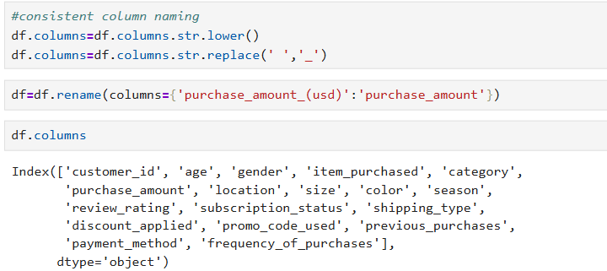

🔹 5. Feature Engineering
✅ Age Group Creation
- Created new column: age_group
- Used quantile-based binning (qcut):
  - Young Adult
  - Adult
  - Middle-aged
  - Senior
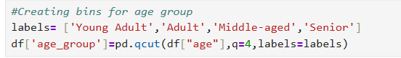
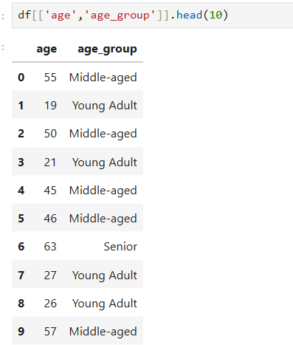

✅ Purchase Frequency Transformation
- Converted categorical frequency into numerical days:
Frequency | Days
Weekly | 7
Fortnightly | 14
Monthly | 30
Quarterly | 120
Annually | 365
- Created new column:
  - purchase_frequency_days
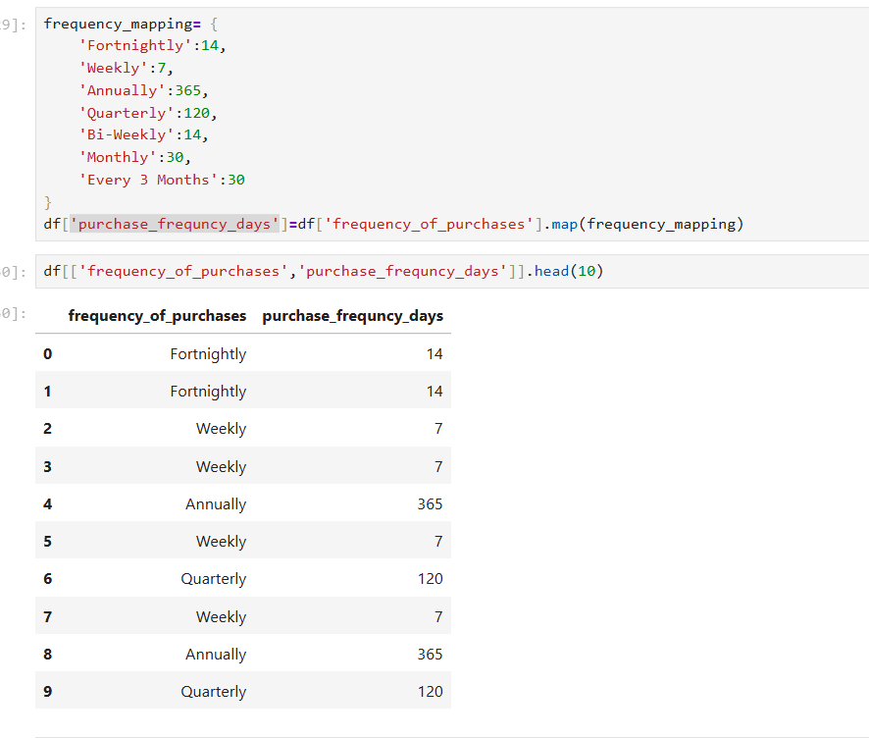

🔹 6. Data Validation
- Verified consistency between:
  - discount_applied and promo_code_used
- Since both columns had identical values:
  - Removed redundant column: promo_code_used
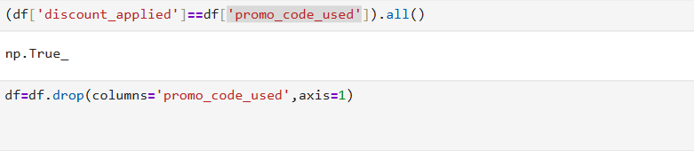

🔹 7. Data Export
✅ Export to MySQL
- Established connection using SQLAlchemy
- Loaded cleaned data into MySQL table:
  - Database: customer_behaviour
  - Table: customer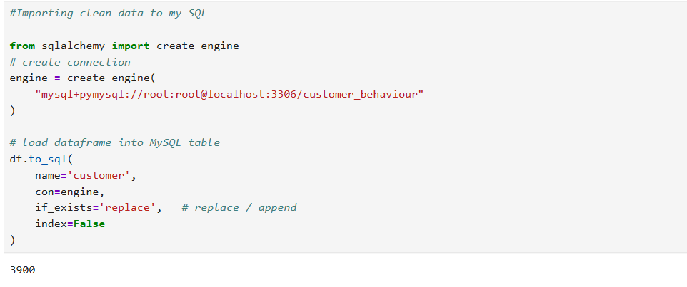
✅ Export to CSV
- Saved cleaned dataset:
  - customer_shopping_behaviour_cleaned.csv

🔹 8. Key Outcomes
- Cleaned and standardized dataset
- Handled missing values effectively
- Created meaningful derived features
- Ensured data consistency
- Prepared dataset for:
  - SQL analysis
  - Power BI visualization

🔹 9. Tools & Technologies Used
- Python (Pandas, NumPy)
- SQL (MySQL)
- Power BI
- SQLAlchemy
- Jupyter Notebook

✅ Final Result
A fully cleaned and transformed dataset ready for data analysis and dashboard creation in Power BI.

📊 Customer Shopping Behavior – SQL Analysis Summary
🔹 1. Database Setup
- Created a new database:
  - customer_behaviour
- Selected the database for analysis
- Used main table:
  - customer

🔹 2. Initial Data Validation
- Verified data using:
  - SELECT * FROM customer LIMIT 10
- Ensured dataset was correctly loaded and structured

🔹 3. Revenue Analysis
✅ Revenue by Gender
- Calculated total revenue grouped by:
  - Male vs Female customers
- Helped understand gender-based spending patterns
select gender, sum(purchase_amount) as Total_Revenue from customer
group by gender;

🔹 4. Discount Impact Analysis
✅ High-Spending Discount Customers
- Identified customers who:
  - Used discounts
  - Still spent more than average purchase amount
- Used:
  - Subquery for average calculation
  - HAVING clause for filtering
select customer_id,sum(purchase_amount),discount_applied as 'Revenue' from customer
where discount_applied='Yes'
group by customer_id
having sum(purchase_amount)> (select avg(purchase_amount) from customer);

🔹 5. Product Performance Analysis
✅ Top 5 Products by Review Rating
- Calculated average review rating per product
- Sorted in descending order
- Selected top 5 products
select item_purchased , round(avg(review_rating),2) as "average_rating" from customer group by item_purchased
order by 2 desc limit 5 ;

🔹 6. Shipping Analysis
✅ Express vs Standard Shipping
- Compared average purchase amount between:
  - Express shipping
  - Standard shipping
- Used:
  - UNION
  - GROUP BY approach for better optimization
select shipping_type, avg(purchase_amount) as 'average_amount'
from customer
where shipping_type in ('Express','Standard')
group by shipping_type;

🔹 7. Subscription Analysis
✅ Subscriber vs Non-Subscriber Behavior
- Compared:
  - Total customers
  - Average purchase amount
  - Total revenue
- Grouped by:
  - subscription_status

select subscription_status ,
count(customer_id) as "Total_Customers",
Round(avg(purchase_amount),2) as "average_amount",
Round(sum(purchase_amount),2) as "Total_Revenue"
from customer group by subscription_status
order by 3,2 ;

🔹 8. Discount-Based Product Insights
✅ Top Products by Discount Usage
- Calculated:
  - Revenue contribution of discounted purchases
  - Percentage of purchases with discounts
- Used:
  - CASE WHEN
  - Aggregation functions

select item_purchased,
Round(100*sum(case when discount_applied='Yes' then 1 else 0 end)/count(*),2) as "purchase_percentage"
from customer
group by item_purchased
order by 2 desc
limit 5;

🔹 9. Customer Segmentation
✅ Customer Classification
- Segmented customers based on previous purchases:
Segment | Criteria
New | = 1 purchase
Returning | 2–10 purchases
Loyal | > 10 purchases
- Used:
  - CTE (Common Table Expression)
  - CASE statement
with CTE as
(
select customer_id, previous_purchases,
case when previous_purchases =1 then "NEW"
when previous_purchases >=2 and previous_purchases <=10 then "Returning"
when previous_purchases>10 then "Loyal"
end as "Customer_order_segment"
from customer
)
- select customer_order_segment,count(*) as "customer_type_cont" from CTE
- group by customer_order_segment ;

🔹 10. Category-wise Product Ranking
✅ Top 3 Products per Category
- Identified most purchased products within each category
- Used:
  - ROW_NUMBER() window function
  - Partitioning by category
with CTE as
(
select category,item_purchased,count(customer_id) as "Purchase_count",
ROW_NUMBER() over (partition by category order by count(customer_id) desc) as "rnk"
from customer
group by category, item_purchased
)
select category,
item_purchased,
purchase_count
from CTE
where rnk<=3;

🔹 11. Customer Behavior Insights
✅ Repeat Customers vs Subscription
- Checked if frequent buyers are also subscribers
- Filtered customers with:
  - previous_purchases > 5
select subscription_status,count(customer_id) as "customer_count"
from customer where previous_purchases>5
group by subscription_status;

🔹 12. Age Group Analysis
✅ Revenue by Age Group
- Calculated total revenue generated by each age group
- Sorted results in descending order

select age_group,sum(purchase_amount) as "Total_Revenue" from customer
group by age_group
order by sum(purchase_amount) desc;

🔹 13. Key Outcomes
- Identified high-value customer segments
- Evaluated impact of discounts on revenue
- Discovered top-performing products
- Compared shipping preferences and spending behavior
- Analyzed subscription impact on revenue
- Built customer segmentation for targeted analysis

🔹 14. SQL Concepts Used
- Aggregate Functions (SUM, AVG, COUNT)
- Grouping (GROUP BY)
- Filtering (WHERE, HAVING)
- Subqueries
- Common Table Expressions (CTE)
- Window Functions (ROW_NUMBER)
- Conditional Logic (CASE WHEN)
- Joins via analytical logic (implicit segmentation)

✅ Final Result
Performed end-to-end SQL analysis to extract business insights, customer behavior patterns, and product performance metrics, enabling data-driven decision-making and dashboard creation in Power BI.

📊 Customer Shopping Behavior – Power BI Dashboard Summary
🔹 1. Objective
The Power BI dashboard was developed to visualize customer shopping behavior, identify key business insights, and support data-driven decision-making.

🔹 2. Dashboard Overview
The dashboard provides a comprehensive view of:
- Customer demographics
- Product performance
- Revenue trends
- Purchase behavior
- Discount and subscription impact

🔹 3. Key KPIs (Key Performance Indicators)
- Total Revenue → Overall sales generated
- Total Customers → Number of unique customers
- Average Purchase Amount → Average spending per transaction
- Total Orders / Transactions → Total number of purchases
👉 These KPIs give a quick snapshot of overall business performance.

🔹 4. Visualizations Used
✅ Revenue Analysis
- Bar Chart:
  - Revenue by Gender
  - Revenue by Age Group
- Insight:
  - Helps identify which customer segment contributes most to revenue

✅ Product Performance
- Top N Products (Bar Chart):
  - Displays top-performing products based on revenue or rating
- Insight:
  - Identifies best-selling and highly rated products

✅ Subscription Analysis
- Clustered Bar / Column Chart:
  - Subscriber vs Non-subscriber comparison
- Metrics:
  - Average Purchase Amount
  - Total Revenue
- Insight:
  - Evaluates effectiveness of subscription model

✅ Shipping Analysis
- Comparison Chart:
  - Express vs Standard shipping
- Insight:
  - Determines if faster delivery influences higher spending

✅ Discount Impact
- Bar / Pie Chart:
  - Discount vs Non-discount purchases
- Insight:
  - Measures how discounts influence buying behavior

✅ Customer Segmentation
- Categorical Chart:
  - New vs Returning vs Loyal customers
- Insight:
  - Helps understand customer retention and loyalty

🔹 5. Filters / Slicers Implemented
- Category
- Gender
- Age Group
- Subscription Status
- Shipping Type
👉 These slicers allow dynamic analysis and interactive exploration of data.

🔹 6. DAX Measures Created
- Total Revenue
- Average Purchase Amount
- Customer Count
- Top N Product Filter
👉 Used DAX functions like:
- SUM()
- AVERAGE()
- COUNT()
- CALCULATE()
- FILTER()

🔹 7. Key Insights Derived
- Certain customer segments contribute significantly more revenue
- Loyal customers generate higher lifetime value
- Discounts influence purchase frequency but not always higher spending
- Subscription users tend to have higher average purchase value
- Top products can be identified for marketing focus

🔹 8. Business Impact
- Helps in targeted marketing strategies
- Supports customer retention planning
- Identifies high-performing products
- Assists in pricing and discount strategies
- Improves decision-making using data visualization

🔹 9. Tools & Technologies Used
- Power BI Desktop
- DAX (Data Analysis Expressions)
- Data Modeling
- Interactive Visualizations

🔹 10. Final Outcome
An interactive dashboard that transforms raw data into meaningful insights, enabling stakeholders to:
- Monitor performance
- Identify trends
- Make informed business decisions

✅ Project Conclusion
This dashboard completes the end-to-end data analytics pipeline:
- Python → Data Cleaning
- SQL → Data Analysis
- Power BI → Data Visualization
👉 Delivering a complete business intelligence solution.

